Isa Dhumabaev. Lab02

**Problem Design**

Two main ways to Osh, that were suggested by Google maps are used in the design of this problem.

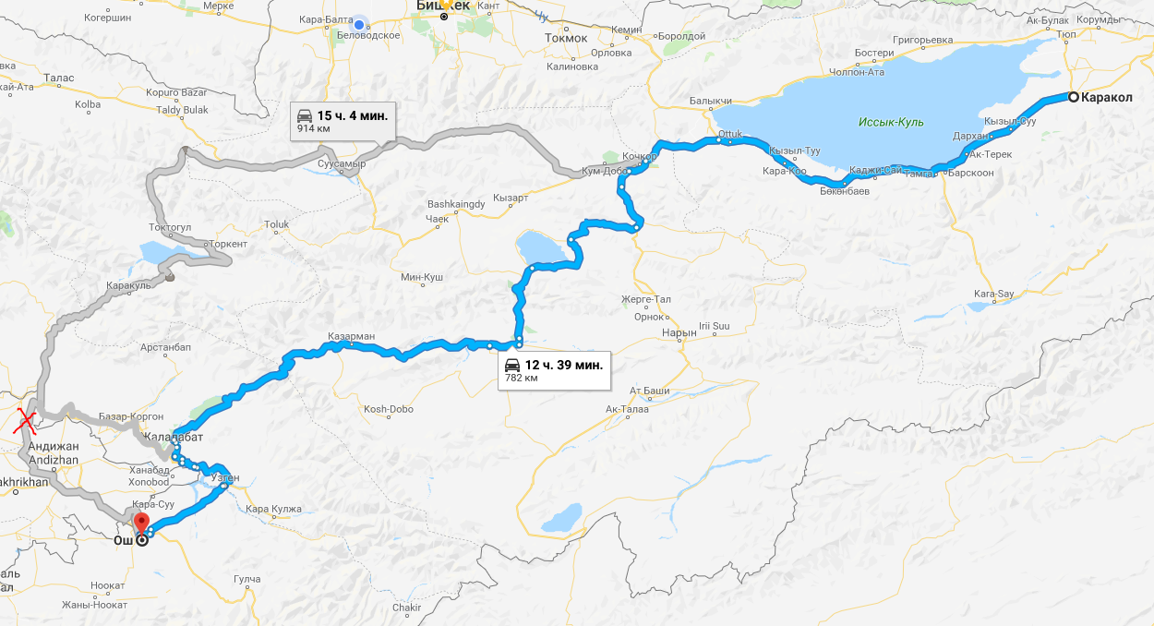

In these map I used only those roads that are on the territory of Kyrgyzstan. That is why second road is modified in my design. You can see that there is a red cross on the map and way to Osh goes through to «Ноокен» and «Жалалабат» node reaches «Ош».

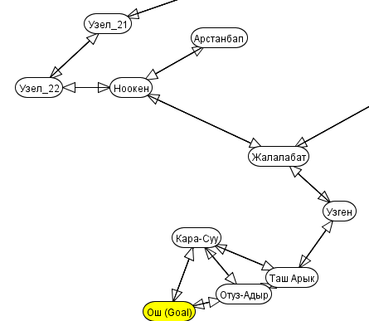

Path cost is based on distance measurement function in Google maps. 1 path cost unit is equals to 1 kilometer. Of course these measurements are very rough and path cost in problem is just approximation.

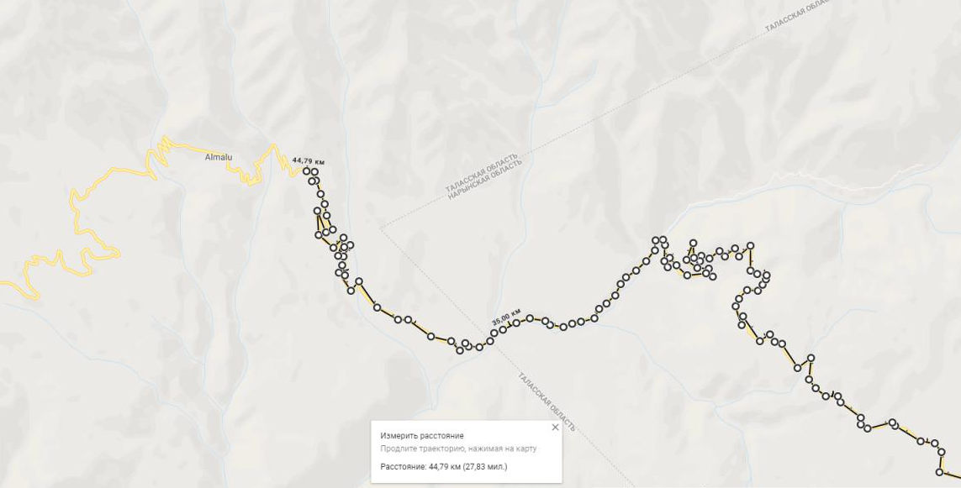

In the actual problem you can see that there is a lot of nodes called «Узел». These are just to show a form of some roads, these don’t affect path cost. For example, area in the following picture represents area around Sonkel’ lake.

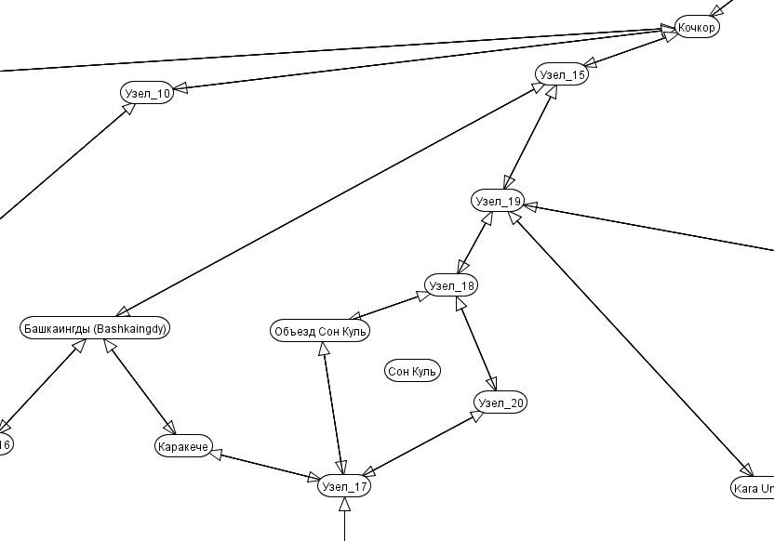

Nodes with name «Узел» match highlighted spots on the map and those that have normal name represent populated locations that are also highlighted.

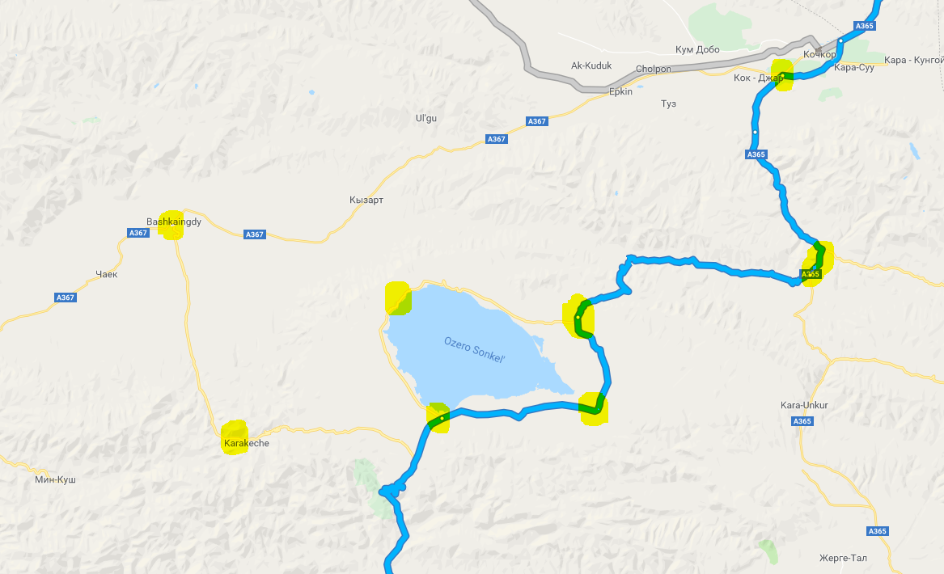

**Search performance**

I used five strategies of search: Depth first, Breadth First, Lowest Cost, Best first, Heuristic Depth First, A*. Each of these strategies are tested with None Pruning, Loop Detection and Multiple Path Pruning with 2000 as maximum step limit. Some search strategies ended up with infinite loop in this area.

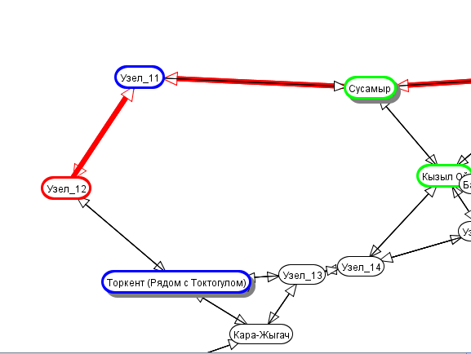

**Best records**

Minimum path cost: 714.81 km in A* with Multiple Path Pruning.

Minimum node expanded: 21 Nodes in Heuristic Depth First with Multiple Path Pruning.

Minimum steps: less than 60 steps in Heuristic Depth First with Multiple Path Pruning.

**Statistics**

**Depth First**

**Pruning mode Steps Cost Nodes Expanded Result**

None > 2000 - - fail

Multiple Path < 100 1019.17 63 success

Loop Detection < 100 1019.17 63 success

**Breadth First**

**Pruning mode Steps Cost Nodes Expanded Result**

None > 2000 - - fail

Multiple Path < 500 753.93 64 success

Loop Detection < 2000 - - fail

**Lowest Cost Search**

**Pruning mode Steps Cost Nodes Expanded Result**

None > 2000 - - fail

Multiple Path < 200 714.81 63 success

Loop Detection < 2000 - - fail

**Best First Search**

**Pruning mode Steps Cost Nodes Expanded Result**

None > 2000 - - fail

Multiple Path < 200 753.93 64 success

Loop Detection < 2000 - - fail

**Heuristic Depth First Search**

**Pruning mode Steps Cost Nodes Expanded Result**

None > 2000 - - fail

Multiple Path < 60 1019.27 21 success

Loop Detection < 60 1019.27 21 fail

**A\***

**Pruning mode Steps Cost Nodes Expanded Result**

None > 2000 - - fail

Multiple Path < 200 714.27 63 success

Loop Detection < 2000 - - fail